NEW from Nestlé Kids!

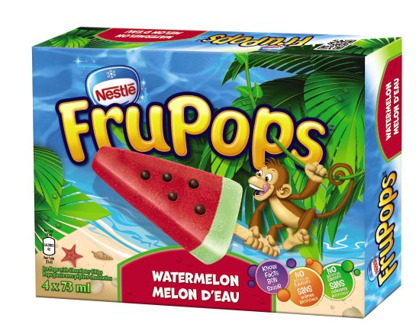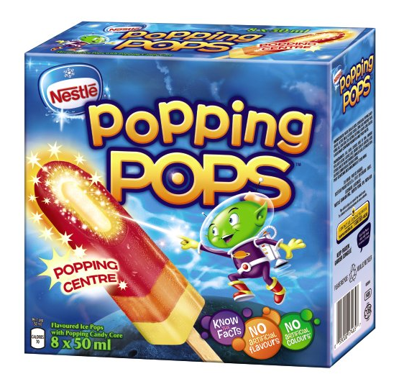

NEW! Nestlé Frupops Watermelon

New delicious watermelon flavoured ice pops come in a fun watermelon slice shape, with a soft texture & chocolatey seeds. A proven international best seller and identified by Nestlé as a global proven innovation, this product contains no artificial colours or flavours. It is a truly unique product which is on trend with the nutritional health and wellness benefits that moms are looking for while offering a fun and playful experience for kids!

NEW! Nestlé Popping Pops

New delicious strawberry, orange and lemon flavoured ice pops come with an exciting surprise popping centre! This product is refreshing and tasty and also contains no artificial colours or flavours. Another global proven best seller in 7 Nestlé Markets, it is a truly unique product which is on trend with the benefits that moms are looking for, while offering a fun and playful experience for kids!

