SMALL BUSINESS GROCERS FROZEN OUT OF ONTARIO ENERGY RELIEF PROGRAM
May 2nd, 2017
Dear Member of Provincial Parliament:
“Small businesses are the heart of many Ontario communities, and we need to help them thrive by creating an environment that encourages growth. Our plan to lower electricity bills by 25 per cent on average provides much-needed relief to small businesses and households across Ontario. Making rates fair is the smart thing to do for Ontario’s economy and the right thing to do for families.”
That statement by Premier Kathleen Wynne in March was something that small businesses in Ontario both agreed with and applauded. As well, in response to questions raised in the Legislature, the most recent on February 23rd, Ministers assured the House that small business grocers would receive the 8 per cent rebate. Yet we now know that small business grocers do not meet the governments criteria for small business and hence do not qualify for the 8% HST rebate we are told is being provided to others. 59.7 per cent of all grocery stores in Ontario are independent small businesses. So the sector that has been arbitrarily excluded from the relief provided to other small businesses is significant. Making rates fair is the smart thing to do, but it is not necessarily what is happening.
Small business grocers are an integral part of the fabric of a myriad of communities across Ontario. Yet they have been struggling to compete on an extremely challenging landscape of growing retail and supplier consolidation, along with the cumulative impact of other costs such as energy, credit card fees, fuel costs and regulatory compliance-- all of which disproportionately impact small business to a much greater degree. This is within the context of margins of 1 to 1.5 per cent in grocery, lower than most other retail sectors.
While most grocers have completed energy retrofits and upgrades, it is a reality of the retail grocery industry that just by the very nature of the business, there are unavoidable higher energy costs embedded in their business model. You can’t, for example, turn fridges and freezers off at night. There are very few small business grocers that do not consume over the 50,000 kW per month threshold that is the cut off to receive the 8 per cent HST rebate. When we first raised this issue with the government in 2016, we were told that a pilot project would be established involving a cross section of our members. That promise was not kept.

Over the coming months, you will be hearing more about this issue from independent grocers that are in your riding. We hope that you will support their simple request that as small business, they be treated as a small business by the Ontario government. We are asking only for fairness and the much needed--and much touted relief--that other small businesses are receiving. Ontario needs to create an environment that for independent grocers, encourages growth, not downsizing. Independent grocers account for $3.5 billion in sales in Ontario and thousands of full and part time jobs. Fair rate relief for grocers will help these small businesses remain price competitive, enable them to continue reinvesting in their businesses, hire people from within their community and buy local products.
As an association, we have generally refrained from putting forward a public litany of complaints or issues, and we have certainly had our share. We think that is an important point that underscores why in this case, we believe the energy issue we bring to your attention is so critical.
Thank you for your consideration and we hope your support of our efforts to ensure that when the government talks about energy relief for small businesses, they mean all small businesses.

Sincerely,

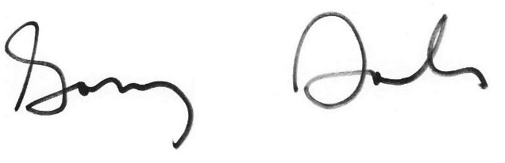

Gary Sands
Senior Vice President, Canadian Federation of Independent Grocers
416-492-3261 gsands@cfig.ca

