FINANCIAL POST – March 14, 2018

Loblaw bread-price fixing gift card nets more backlash as federal privacy commission seeks info

The federal privacy commission wants more information about Loblaw's decision to ask some customers for driver's licences or utility bills to get a gift card
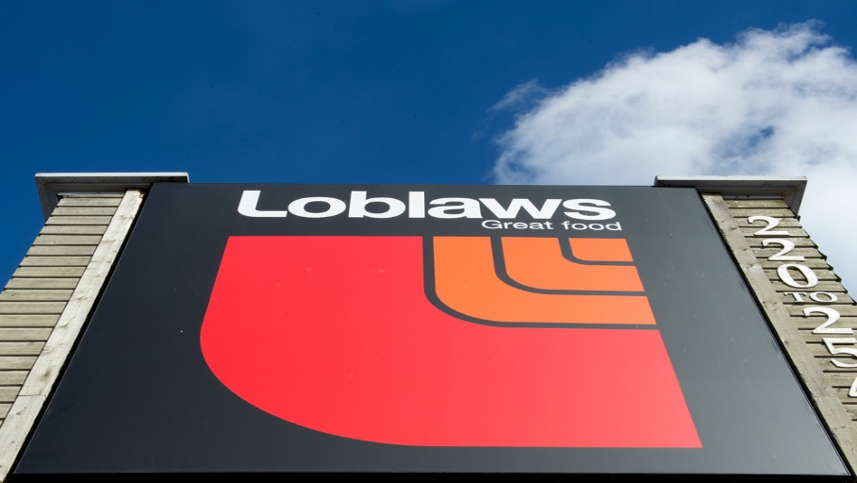Loblaw has said it is only collecting personal information for verification purposes and will then destroy it.Peter J. Thompson/National Post

The Canadian Press
March 14, 2018
12:40 PM EDT

'Why the hell are they at $1.88?': Inside the damning allegations of Canada’s bread price fixing scandal

Loblaw's $25 gift card terms in bread-price fixing offer not misleading, judge rules

Terence Corcoran: Canada’s worst price-fixing cartels aren’t the bread makers. It's politicians

OTTAWA — The federal privacy commission has asked Loblaw Companies Ltd. for more information about its decision to request some customers to provide additional personal information to secure a gift card related to the alleged bread price-fixing scandal.
Privacy concerns have been raised by customers about the grocer’s request for information such as a scan of their driver’s licence or utility bill in order to receive the card.
The company has said it is only collecting the information for verification purposes and will then destroy it.
It has said the vast majority of customers won’t be required to make the additional step, but it has not provided details as to how they are choosing to single out some people.
Loblaw has offered customers a $25 gift card as a goodwill gesture after admitting participating in what they say was an industry-wide arrangement to fix bread prices.
On its website, the privacy commissioner notes that the stringency of authentication processes should be commensurate with the risks to the organization as well as to the individual.

