A quarter of Canadian small businesses impacted by rail blockades: CFIB

Alicja Siekierska
Yahoo Finance CanadaFebruary 25, 2020
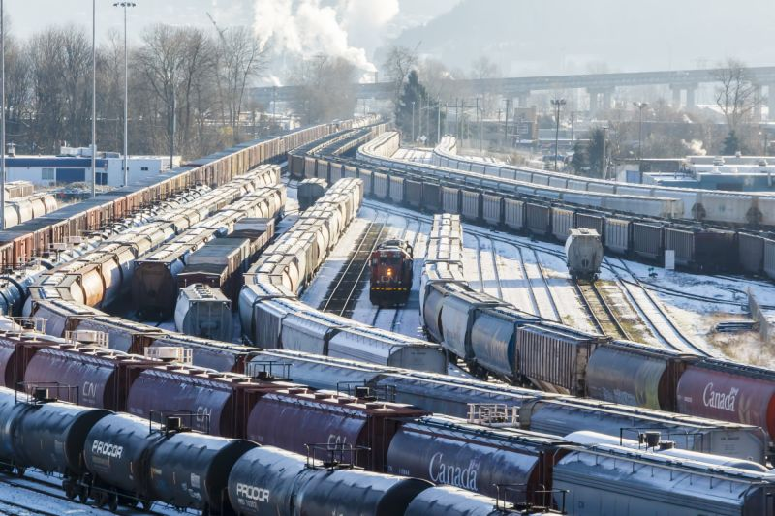
A quarter of Canadian small businesses impacted by rail blockades: CFIB
More
A day after police dismantled an anti-pipeline blockade that had brought a portion of CN Rail’s network to a halt, parts of Canada’s railway system faced additional disruptions as protests continued in parts of the country.
Several new blockades appeared Tuesday, including one in Hamilton, Ont. that disrupted the Go Transit commuter service between Hamilton and Niagara Falls. Another blockade was put in place late Tuesday afternoon, blocking service in Toronto. A group called Rising Tide Toronto claimed responsibility for the blockade.


Rising Tide Toronto@RisingTideTor

Fire burning at the rail blockade in response to the raid on Tyendinaga, currently blocking East West rail lines. #Reconcilliationisdead #ShutDownCanada #Wetsuweten #AllEyesOnTyendinaga #WetsuwetenStrong #AllEyesOnWetsuweten #RCMPOut #NoCGL #WetsuwetenSolidarity
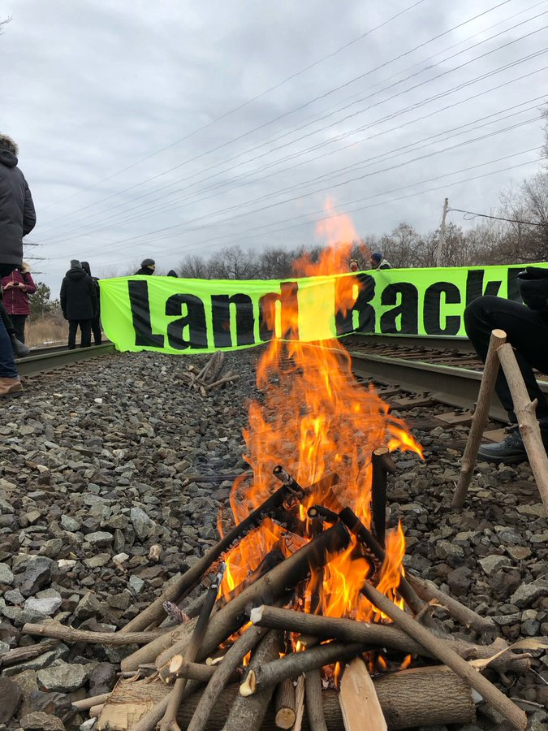

66
5:03 PM - Feb 25, 2020
Twitter Ads info and privacy

56 people are talking about this

On Monday, Ontario’s provincial police had dismantled a rail blockade on Tyendinaga Mohawk Territory near Belleville, Ont., arresting several protestors in the process. The blockade, which had been in place for more than two weeks, had brought some of CN’s operations to a halt.
CN spokesperson Jonathan Abecassis did not confirm whether the railway had resumed service following the removal of the blockade, or when it is expected to.
“The situation is being closely monitored,” he said.
Many industries have warned that if the blockades are not removed, businesses will be forced to cut production and layoff employees as inventory runs out. CN and Via Rail, which uses CN’s railway track, have temporarily laid off approximately 450 and 1,000 workers, respectively.
According to the Canadian Federation of Independent Business (CFIB), nearly a quarter of businesses said they have been negatively affected by the rail blockades, losing an average of $60,000 since demonstrators put up the blockades. The CFIB said in a statement released Tuesday that one business owner has lost over $80,000 and has laid off all staff as the cost of shipping skyrocketed.
“We’re now at the point that this is affecting a huge cross section of businesses, right across the industry spectrum and right across the country,” Dan Kelly, CFIB’s chief executive, said in an interview. He said that, at first, the impact of the blockades were being felt largely by the agriculture, natural resource and manufacturing industries. It has since spread.
“This will now have a significant impact on restaurants, on retail and the wholesale business. There are few areas of business that are not affected,” Kelly said.
Some grocery stores may also be facing product shortages if rail service is not fully restored, an industry group is warning.
Some parts of the country are already grappling with a shortage of products, particularly western Canada, said Gary Sands, vice president of public policy at the Canadian Federation of Independent Grocers (CFIG). If regular rail operations do not resume, the shortages will be exacerbated.
“It’s already starting to be felt, but what we’ve heard from our members is that in another three to five days it’s going to become more pronounced in terms of food shortages,” Sands said in an interview.
“That’s going to result in financial losses and could increase prices for consumers.”
With files from the Canadian Press
Download the Yahoo Finance app, available for Apple and Android and sign up for the Yahoo Finance Canada Weekly Brief.

