ASAP

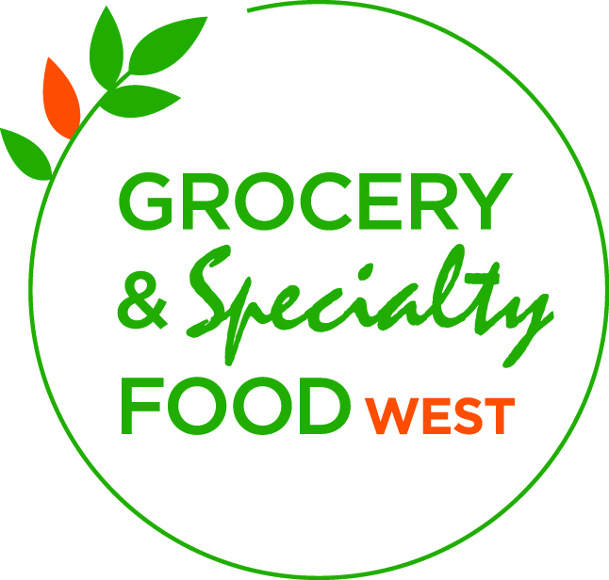

Company Name: _________________________________________
Booth Number: __________________________________________
Square Feet: ____________________________________________
Contact Name: __________________________________________
Email: __________________________________________________
Phone: _________________________________________________

Exhibit Design Form
Please review the RULES & REGULATIONS section to ensure your exhibit meets the outlined requirements. In some instances, aspects of your booth MUST BE APPROVED by Show Management, the Vancouver Convention Centre and/or the Vancouver Fire Department.
Please submit this form for approval even if you are using the same booth that you used in the past.

BOOTH TYPE:
  | Basic Pipe & Drape |   | Hardwall/Custom Booth
  | Pop-Up |   | System (Gem System)

BOOTH DETAILS YES NO
1. Exhibit Configuration is 200 square feet or more ➔       
2. Exhibit has roof/mezzanine/canopy-Please submit diagram to Show Manager ➔    
3. Exhibit structure exceeds 8’ in height ➔     
4. Exhibit has signs, banners or lights over the 8’ height restriction➔    
5. Exhibit has a raised platform    
6. Sampling food and/or beverage
— Please complete Food Sampling Form and send to jherdsman@cfig.ca .    
Please indicate what you will be sampling:
Only 2 oz. samples or sample size products allowed. Attendees will not be allowed to exit with full size
products. Help us in the effort to limit waste and prevent product loss. Other restrictions may apply.

7. Exhibit material exceeds 10,000 lbs. gross weight    
8. Exhibit material exceeds 300 lbs./sq. ft. limit    
9. Materials/processes/equipment require special permit    
10. Exhibit has motorized vehicle/combustion engine    

11. Exhibit contains liquid fuels/natural gas/propane
(Allow 6 weeks’ notice to process request)
   

12. Exhibit contains cooking appliances and/or hot oil    

13. Exhibit contains hazardous material which does not comply with Government
Regulations on material handling in the work place
  
14. Exhibit contains helium or large inflatable balloons    
15. Exhibit has electrical equipment requiring approval (i.e. CSA Approved)    
16. Exhibit will have product to donate to the Food Bank    
➔ NOTE: If questions 1 – 4 are answered “YES” specific design plans must be submitted for approval by Show Management.

Details to all questions answered, “YES”, must be provided:

Return to: jherdsman@cf@cfig.ca OR Fax: (416) 492-2347

